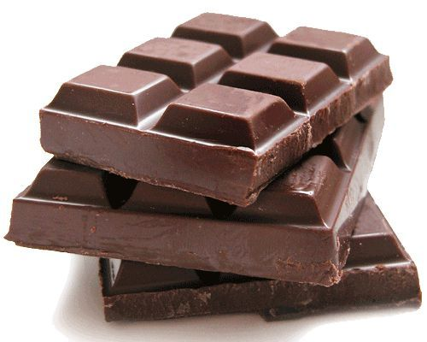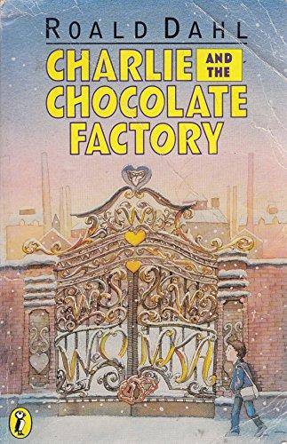 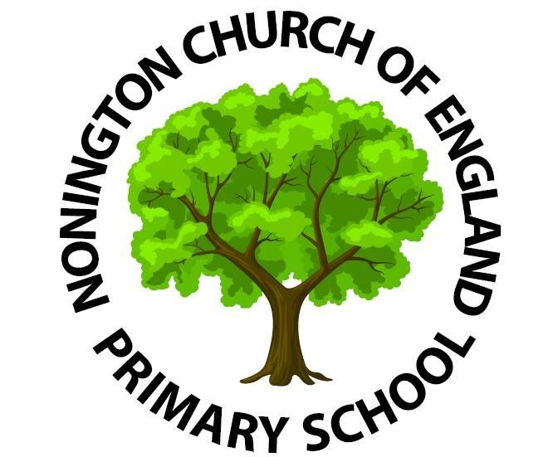

This term our theme will be ‘Chocolate’.

Mathematical Development/Maths

This term we will continue to consolidate addition, subtraction, multiplication and division. Please continue to support your child with learning their 2, 5, and 10 times tables. We will be focusing on fractions of shapes and numbers, using ½, ¼, and ¾. We will also cover measuring using length.

History/Geography

The children will learn about where cacao is grown. We will discuss and sequence the history of chocolate and learn how to make a Mayan hot chocolate.

Art/DT

The children will design and make a clay mug based on ancient Mayan designs and patterns. We will also design musical instruments to accompany our very own Oompa Loompa song and dance.

Understanding the World/Science

The children will conduct a scientific experiment to find a suitable material to make a chocolate bar wrapper. They will learn about the cacao plant, healthy eating, exercise and continue to observe seasonal changes.

PE - On Tuesday’s the class will be doing gymnastics. On Friday’s we will explore an Oompa Loompa song from Charlie and the Chocolate Factory and use different dance techniques to create a sequence using musical instruments and ribbons.

Communication and Language/English

This term the children will be writing an adventure story. First, they will explore stories by Anthony Browne and take a closer look at Gorilla as part of our focus for Book Week. We have begun reading Charlie and the Chocolate Factory by Roald Dahl and this will develop their understanding of setting and character descriptions which will be used to invent their very own chocolate room in Willy Wonka’s factory.

RE

Why does Easter matter to Christians?

Our RE focus for this term is SALVATION**.**

Ladybirds Class R/1/2 Curriculum Newsletter - Term 4